18.26: Since this gas is at standard conditions, the volume will be 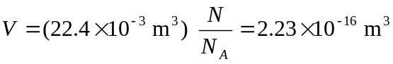, and the length of a side of a cube of this volume is 